Nashville, Tennessee

The Tennessee Board of Regents for the State University

and Community College System of Tennessee upon the recommendation

of the Faculty hereby confers upon

{{fullName}}

Who has completed the studies and fulfilled all the requirements
set forth by the College for the {{degreeType}} in

{{major}}
{{concentration}}
{{honors}}

in testimony whereof the seal of the State and signatures as authorized by
the Tennessee Board of Regents and hereunto affixed
this {{graduationDate}}
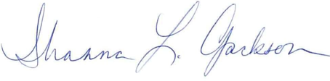

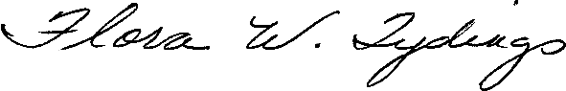
President of the College
Governor

Chancellor, Tennessee Board of Regents

